NomadReady PH

Problem Statement

The Philippines has strong potential to attract digital nomads, but many local destinations are difficult to evaluate for remote work. Digital nomads need reliable internet, quiet work-friendly spaces, long-stay accommodations, safety information, healthcare access, transport options, and local services.

Today, this information is scattered across Facebook pages, Google Maps reviews, blogs, and outdated websites. As a result, digital nomads often choose only popular destinations, while smaller LGUs and local tourism businesses miss the opportunity to attract long-stay visitors.

LGUs also lack a simple way to measure how “digital nomad ready” their destination is and identify what they need to improve.

Solution

Our solution is a web app that helps digital nomads find Philippine destinations where they can live, work, and explore, while helping LGUs measure and improve their readiness for this market.

The AI acts as a digital nomad matching assistant and an LGU readiness advisor. For digital nomads, it uses a chatbot-style planner to understand their needs such as budget, stay length, internet requirements, lifestyle, safety, and preferred activities. It then recommends suitable destinations, work-friendly cafés, long-stay accommodations, nearby services, estimated costs, and weekend travel options.

For LGUs, the AI analyzes destination data such as internet access, coworking spaces, accommodations, transport, healthcare, safety, and local attractions. It generates a Digital Nomad Readiness Score and suggests practical improvements, such as certifying cafés as work-friendly spots, publishing Wi-Fi speed information, promoting monthly stay packages, creating brownout backup guides, and organizing community events.

This combines AI chatbot assistance, recommendation matching, and data prediction/scoring to make tourism destinations easier to discover, evaluate, and improve for the digital nomad market.

Expected Impact:

NomadReady PH can help attract longer-stay tourists, increase spending in local communities, promote lesser-known destinations, support local MSMEs, and help LGUs prepare for the future of tourism.

AI Integration / Solution

Our web app uses AI to help digital nomads quickly find destinations where they can live, work, and explore based on their needs.

Instead of manually checking Facebook pages, Google reviews, blogs, and outdated websites, the user can simply ask:

“Where can I stay in Aklan for one month with reliable internet, affordable accommodation, and beach access on weekends?”

The AI will recommend the best location, work-friendly cafés, long-stay accommodations, nearby services, estimated budget, and weekend activities.

For LGUs, the AI analyzes destination data such as internet availability, work-friendly spaces, accommodations, safety access, transport, healthcare, and local attractions. It then generates a Digital Nomad Readiness Score and suggests improvements, such as:

- certify cafés as work-friendly spots
- publish Wi-Fi speed information
- promote monthly stay packages
- create a brownout backup guide
- organize community events for remote workers

The AI can also power a chatbot that answers digital nomad questions using verified local tourism data.

In simple terms, the AI acts as a digital nomad matching assistant and an LGU readiness advisor, helping travelers make better decisions while helping destinations become more competitive in the digital nomad tourism market.

THE PITCH

The Philippines now has a Digital Nomad Visa, but many local destinations are not ready to capture this opportunity. Digital nomads need more than beaches — they need reliable internet, work-friendly spaces, long-stay options, safety information, and local community.

NomadReady PH is an AI-powered tourism platform that helps remote workers find the best places to live, work, and explore in the Philippines, while helping LGUs assess and improve their digital-nomad readiness.

We are starting with Western Visayas, where destinations like Iloilo, Aklan, Boracay, Antique, and Guimaras can attract long-stay visitors and distribute tourism income to local communities.

The Technicals

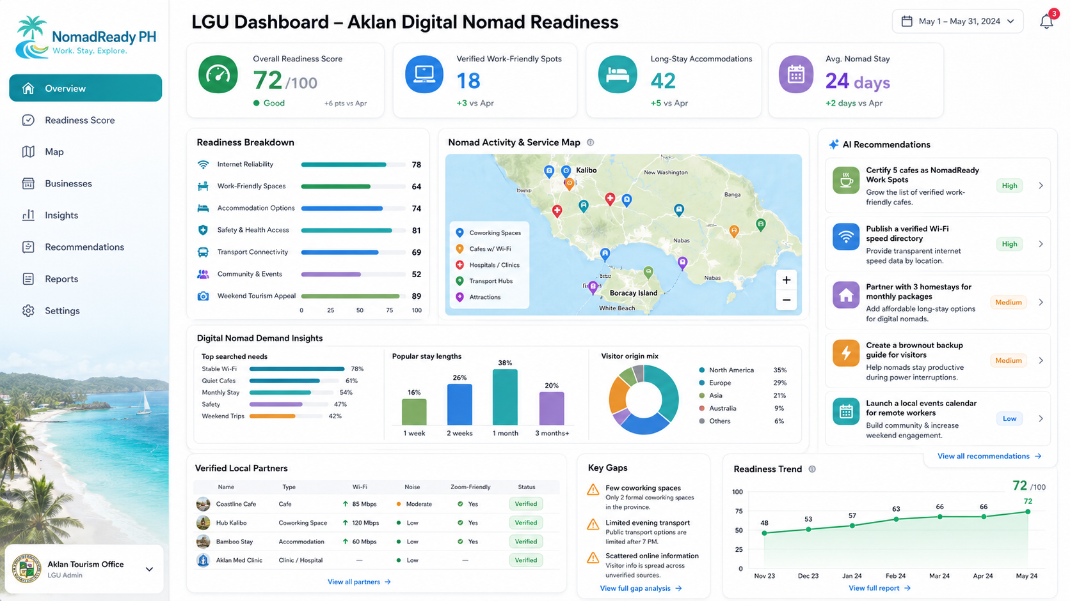
UI - LGU

UI - Tourist
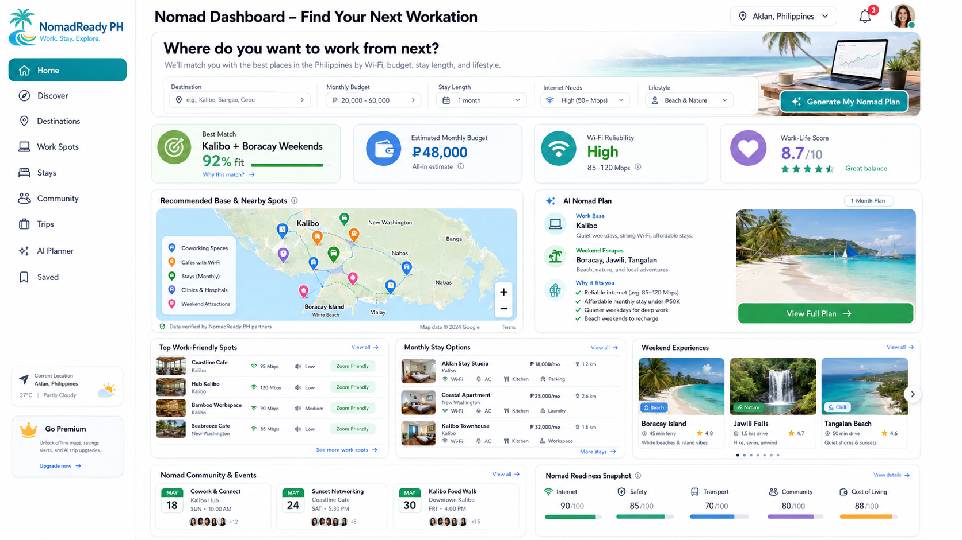

Side 1: LGU / Tourism Office Dashboard
Purpose:
Help LGUs see how ready their destination is for digital nomads and what they need to improve.
Main users:
- LGU Tourism Officer
- Municipal/City Tourism Staff
- Provincial Tourism Office
- Admin / Super Admin
Main outputs:
- Digital Nomad Readiness Score
- Destination profile
- Verified work-friendly places
- Local partner directory
- Gap analysis
- AI recommendations
- Reports

Side 2: Digital Nomad Web App
Purpose:
Help digital nomads discover and compare destinations where they can work and stay.
Main users:
- Foreign digital nomads
- Local remote workers
- Long-stay tourists
- Freelancers / founders / remote employees
Main outputs:
- Destination matcher
- Workation plan
- Recommended base location
- Work-friendly spots
- Monthly stay options
- Weekend trips
- Safety and cost guide

Side 3: Platform Admin
Purpose:
Manage the whole system across LGUs, destinations, users, submissions, verification, and scoring rules.

Main users:
- NomadReady PH internal admin
- System owner
- Support/moderator

Main outputs:

- Manage LGU accounts
- Approve destinations
- Manage scoring criteria
- Review reported data
- Manage featured locations
- Audit AI recommendations
- Control public visibility

Side 4: Local Business / Partner Portal
(This may be optional for MVP, but important later.)
Purpose:
Allow cafés, homestays, coworking spaces, resorts, clinics, gyms, and tour operators to submit or update their listing.
Main users:
- Café owners
- Accommodation owners
- Coworking space operators
- Tour providers
- Local service providers
Main outputs:
- Business listing
- Wi-Fi info
- Photos
- Monthly rates
- Amenities
- Verification status
- NomadReady badge
For MVP, LGU staff can encode these businesses manually first. We do not need a separate business portal immediately.

User Roles
1. Super Admin - NomadReady PH team.
Can manage:
- All LGUs
- All destinations
- All users
- Scoring rules
- AI prompts/rubrics
- Platform-wide reports
- Approval and verification
2. LGU Admin - This can be the tourism officer or authorized LGU account.
Can manage:
- Their own destination profile
- Local business listings
- Work-friendly spots
- Accommodation listings
- Events
- Safety information
- Healthcare and emergency data
- Transport info
- Readiness data
- Reports
3. LGU Staff / Editor - Can encode and update data but may not publish or approve.
Can manage:
- Draft listings
- Draft destination data
- Events
- Partner information
(This user will be in Phase 2 if we continue the project.)(Not needed in the hackathon build)

4. Provincial Tourism User - This is different from municipal LGU, this can be provincial tourism officer. Can view multiple municipalities/cities under the province.

Example:
Aklan Provincial Tourism can view:
  - Kalibo
  - Malay / Boracay
  - Tangalan
  - Buruanga
  - New Washington
  - Numancia
Can compare readiness scores across destinations.
(This user will be in Phase 2 if we continue the project. Not needed in the hackathon build)

5. Business Partner - Café, resort, homestay, coworking, gym, clinic, transport, tour operator.
Can submit:
- Business details
- Wi-Fi speed
- Amenities
- Monthly rates
- Photos
- Opening hours
- Contact info
(This user will be in Phase 2 if we continue the project. Not needed in the hackathon build)

6. Digital Nomad - Uses a public app.
Can:
- Search destinations
- Use destination matcher
- Ask AI planner
- Save places
- View recommended stays/work spots/trips
- Compare locations

Phase 1: LGU Dashboard MVP
This is where we should start.
Core screens:
- LGU Login / Account
- LGU Dashboard Overview
- Destination Profile
- Readiness Score Breakdown
- Local Partner Directory
- Work-Friendly Spots
- Accommodations
- Safety & Services
- AI Recommendations
- Reports
MVP outcome:
LGU can encode destination data, see readiness score, view gaps, and receive AI-generated improvement recommendations.

Phase 2: LGU Data Management
Add deeper modules:
- Business verification
- Wi-Fi speed records
- Events calendar
- Tourism attractions
- Monthly stay packages
- Transport info
- Healthcare/emergency contacts
- Upload supporting documents

Phase 3: Digital Nomad Public App
Core screens:
- Destination matcher
- Destination result page
- Workation plan
- Work spots directory
- Stay options
- Weekend trips
- Saved plans
- AI travel assistant
Phase 4: Admin Console
Core screens:
- Manage LGUs
- Manage provinces/destinations
- Approve submitted listings
- Manage scoring rubric
- Manage platform content
- Monitor AI output
- Analytics
Phase 5: Partner Portal(Do not build yet)
Core screens:
- Business onboarding
- Submit listing
- Update amenities
- Upload proof/photos
- View verification status
- NomadReady badge

